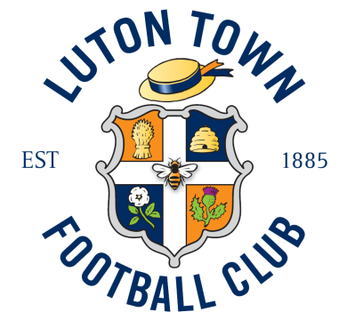

JOB DESCRIPTION – PRESS & MEDIA ASSISTANT

1. JOB TITLE

Responsible to: Press & Media Manager

Responsible for: n/a

2. MAIN PURPOSE

To provide effective support on the Press, Media, Communications and Marketing functions of the business.

This is a permanent full-time role requiring flexibility to work some evenings and weekends, including all home and away first-team matchdays for which lieu time is accrued.

3. RESPONSIBILITIES

3.1 Matchday programme

Contribute to the matchday programme as required by the Press & Media Manager, including but not limited to match reports, player and manager interviews and features, for example.
Assist the Press & Media Manager, supplying articles and images to the programme designer for the programme.
3.2 Press & Media

Assist in the writing of press releases and distribute to appropriate press contacts as required by the Press & Media manager.
Assist with press and media enquiries on matchday, acting as a contact for the press box/media suite.
Assist with the weekly pre-match press conferences at the training ground as required.
3.3 Reporter / Journalist

Attend and cover other Club activities/events in the community and help to raise the profile of the Club in a positive way.
3.4 Digital Communications

Helping to produce and deliver first class football content across Luton Town’s social channels, with responsibility for monitoring and posting.

Help ensure that important Club announcements are delivered online in a timely and professional way via the Club’s website and other distribution channels.
Maintain and update sections of the Club website, iFollow and YouTube channels.
Conduct, record and edit player/manager matchday interviews and disseminate through our website and social media channels.
3.5 Matchday Support

Attend home and away first-team matches and produce high quality written coverage for use on our website/social media channels/matchday programme, including development team and youth team matches as required by the Press & Media Manager.
Help oversee post-match press conference and filming of manager and player interviews, editing and uploading to publish on Club channels.
3.6 Marketing Support

Assist the Marketing & Communications Manager where required with the delivery of Marketing plans across the various departments of the Club.
Acts a brand ambassador, helping to answer questions from colleagues and external parties with regards to brand guidelines and logo use.
Assist the Marketing and Communications manager with the delivery of graphic design for marketing campaigns using InDesign, Photoshop and other software, with training and guidance.
3.7 Health & Safety

Lead by example being diligent and observant at all times.

Ensure safety & risk are considered within all projects.

4. QUALIFICATIONS & SKILLS

  - Essentials

- A degree in a relevant subject area (PR, English, marketing, journalism or media related)
- Full, clean UK driving licence and access to a car
- Previous experience of a football club’s media department
- Ability to meet deadlines and excellent time-management skills
- Ability to produce accurate written content across a variety of platforms
- Excellent communications skills across all levels with directors, coaches, players and fans
- Experience of uploading content on social media platforms
- Experience of writing web content and editing/uploading videos
- Experience of interviewing footballers/professional sports people

  - Desirables

- Knowledge of Adobe design and editing suite
- Ability to design/edit social media assets and Club style graphics
- One year’s experience of an EFL club’s media department
- Knowledge of an EFL Digital club’s website CMS and Dataco/IPBS system

5. PERSON SPECIFICATION

Committed, enthusiastic and passionate about football and the delivery of all news and information from Luton Town Football Club.

Ability to work as part of a team as well as using one’s own initiative to produce engaging content across a range of platforms.

Excellent interpersonal skills with a variety of different personnel at the Club.

Strong IT skills and meticulous attention to detail.

Able to adapt to the demands of the job and different requests from various media outlets, players and coaches.

Dedicated to self-improvement and continuous professional development.

Willing to follow and promote the philosophy of the Club.

Be an ambassador for Luton Town Football Club, presenting the Club in a positive image at all times.

6. SAFEGUARDING STATEMENT

Luton Town FC is committed to safeguarding the welfare of children and young people and expects all employees and volunteers to endorse this commitment. This post requires Enhanced Criminal Records Checks and may include checks against the Barred Lists, as such it is exempt from Rehabilitation of Offenders Act (1974). Therefore, all convictions including spent convictions that have not been subject to filtering by the DBS should be declared. Relevant information and / or documents will be distributed as part of the recruitment process.

7. EQUALITY STATEMENT

The employee must at all time carry out their duties with due regard to Luton Town FC policies and procedures.

The employee must ensure a positive commitment towards equality and diversity by treating others fairly and not committing any form of direct or indirect discrimination, victimisation or harassment of any description and to promote positive working relationships between all internal and external stakeholders.

The employee must contribute to encouraging equality and respecting diversity by embedding such values in the workplace and challenging inappropriate behaviour and processes.

